Practical: 1

# Aim: Observing different cables and connectors, configuring WIFI Access Point.

* **Types of Cables:**
  1. Ethernet cables
  2. Twisted-pair cables
  3. Coaxial cables
  4. Optical audio cables
  5. Fiber Optic cables

### Ethernet Cables:

* Ethernet cables are networking cables that are used to connect devices such as computers, routers, and switches to each other and to form a local area network (LAN). They are made of copper wire and have connectors on each end that allow them to be plugged into Ethernet ports. Ethernet cables come in a variety of types, including Cat5, Cat5e, Cat6, and Cat7, which differ in terms of speed and performance.

### Twisted-pair cables:

### Twisted-pair cables are a type of wiring that consists of two insulated copper wires that are twisted together. They are used in many different types of communication systems, including telephone lines, Ethernet networks, and serial data transmission.

### The twisting of the wires helps to reduce interference and crosstalk, which can cause errors in the transmission of data. There are several types of twisted-pair cables, including unshielded twisted-pair (UTP) and shielded twisted-pair (STP). UTP cables are the most common type and are used in many networking and telecommunications applications, while STP cables are used in environments where there is a higher level of electromagnetic interference. Twisted-pair cables are popular because they are relatively cheap, easy to install, and can transmit data over long distances.

### Coaxial cables:

* Coaxial cables are a type of electrical cable that consists of a single copper wire at the center, surrounded by insulation and a layer of braided wire mesh. They are used to transmit data, video, and audio signals over long distances, and are commonly used in cable television and broadband internet systems.
* Coaxial cables are known for their ability to transmit high-frequency signals with minimal interference, making them ideal for applications where signal quality is important. They are also resistant to electromagnetic interference, which makes them suitable for use in environments where there may be a lot of electrical noise. Coaxial cables are available in a variety of sizes and can be used for both indoor and outdoor applications.

### Optical audio cables:

* Optical audio cables, also known as TOSLINK cables, are used to transmit digital audio signals from one device to another. They are made of fiber optic strands, which are thin strands of glass or plastic that are used to transmit light.
* Optical audio cables are used to connect audio devices such as CD players, DVD players, and home theater systems to speakers and other audio equipment. They are known for their ability to transmit digital audio signals with very little loss in quality, making them a popular choice for high-fidelity audio systems.
* One of the main advantages of optical audio cables is that they do not suffer from electromagnetic interference (EMI) or radio frequency interference (RFI), which can degrade the quality of an audio signal. This makes them an ideal choice for use in environments where there is a lot of electrical noise.

### Fiber Optic cables:

* Fiber optic cables are thin strands of glass or plastic that are used to transmit data as pulses of light. They are used in a variety of communication systems, including telephone lines, internet connections, and cable television.
* Fiber optic cables are known for their high bandwidth, which makes them capable of transmitting large amounts of data over long distances at high speeds. They are also immune to electromagnetic interference (EMI), which makes them suitable for use in environments where there may be a lot of electrical noise.
* In addition, fiber optic cables are resistant to physical damage and can be used in outdoor applications. One of the main advantages of fiber optic cables is that they have a very low signal loss, which allows them to transmit data over long distances with minimal degradation in quality.

# Types of Connectors:

### Ethernet Cable Connectors

1. **Coaxial Cable Connectors**

### USB Connectors

1. **Fiber Optic Cable Connectors**

### Ethernet Cable Connectors:

* RJ45 connectors are used for CAT6 cables and CAT5e cables. These connectors for twisted-pair Ethernet cables are similar in appearance to a standard telephone cord connector. They are wider, however, because they have eight conductors compared to only four conductors on a telephone jack.
* To install these types of wiring connectors, a stripping tool is used to expose the twisted pairs of wires from the cable, which are then positioned into the appropriate slots on the terminal plug. The connector is then crimped to the cable using a crimping tool.

### Coaxial Cable Connectors:

* BNC connectors are a type of F-series connectors commonly found in households. This type of connector for RG59 or RG6 coaxial cable is used for cable television equipment, broadcast TV antennas and CCTV security camera installations. They are easy to connect and disconnect from equipment and provide inexpensive, stable connections to these communications devices and other cables.
* To install a BNC connector, use a stripping tool to remove protective shields from the cable. The connector is pushed onto the end and then squeezed around the conductive material using a special compression crimper.

### USB Connectors:

* USB connectors are the most familiar to the majority of people. USB (Universal Serial Bus) connectors typically join external devices to a personal computer or are used for mobile phone charging. There are adapters that will allow an Ethernet cable to connect directly to a USB port, though this type of setup would be a temporary solution for networking.

### Fiber Optic Cable Connectors

* Fiber optic connectors require different types of connectors from those used with coax or twisted-pair cables, such as CAT5e. These types of connectors in networking must align glass fibers with precision to allow for communication. If you choose to use

optical cable over twisted pair Ethernet, you may need to install a special adapter in your computer to utilize various fiber optic cable connector types.

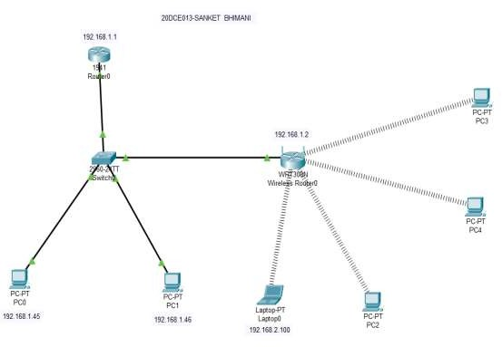

* SC connectors: A push-pull latching mechanism in SC connectors provides quick insertion and removal while also ensuring a positive connection.
* ST connectors: ST connectors were among the first connectors in networking fiber optic cable. These use a plug and socket, which is locked in place with a twist-style bayonet lock.
* LC connectors: LC-type connectors have a squarish duplex configuration. Installation of this small form factor (SFF) connector is quick for rapid repair of replacement needs.

# Configuring Wifi access point.

## We are try to understand whole configuration of wifi access point through below figure.

Fig 1.0

* In Fig 1.0 we describe whole structure of connection through wireless router to PC,laptop and switches.

### 1. Router Configuration:

* In which we are linked router.

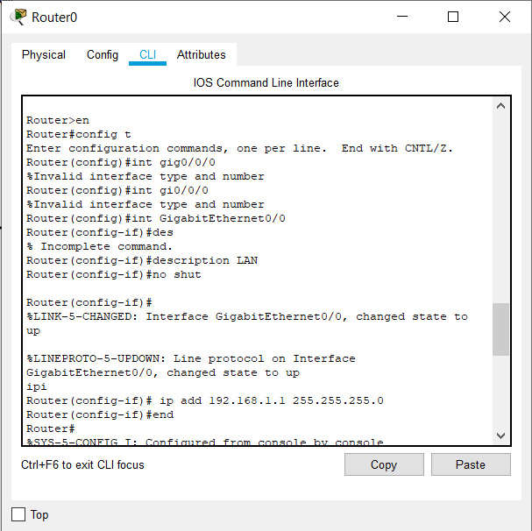

Fig 1.1

* Fig 1.1 describe link between router to switch configuration.

### 2 . Laptop Configuration:

* On laptop we need to select the Wireless Card and then check the ip address which we will be automatically gained from the wirless router.

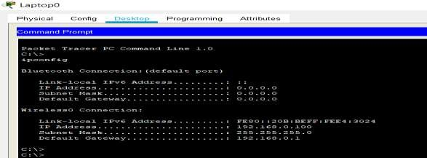

Fig 1.2

* Now we can connect the wireless router from the PC using the IP address is 192.168.0.1.

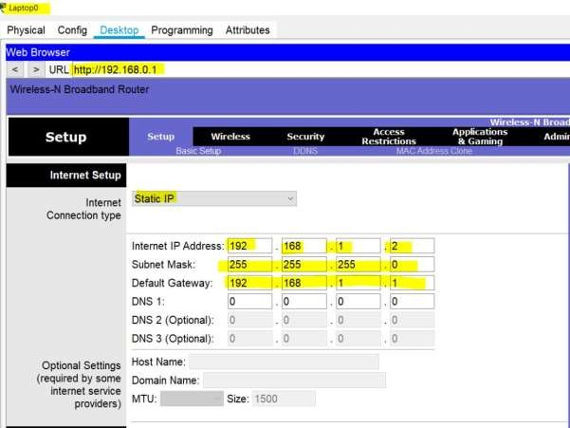

* Default username & password – admin.



* Now change the WAN IP which is under Internet Setup.
* Now lets change the LAN IP address under Network Setup.

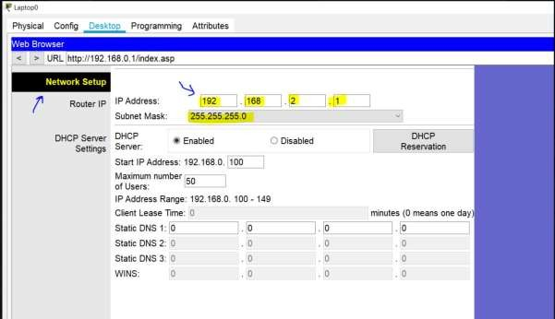

* This will interrupt the connection and we will get the timeout.
* Lets check if the laptop got the new address.

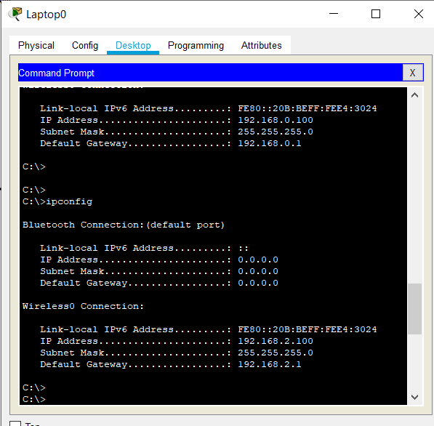

* After ping the PC0 and PC1.

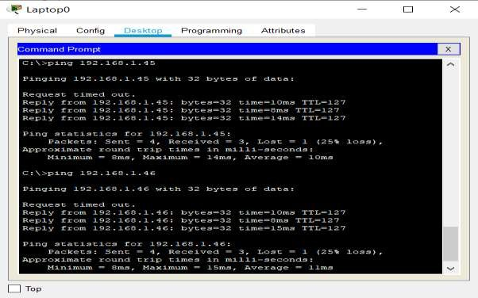

* Let change the Wireless router SSID and password.

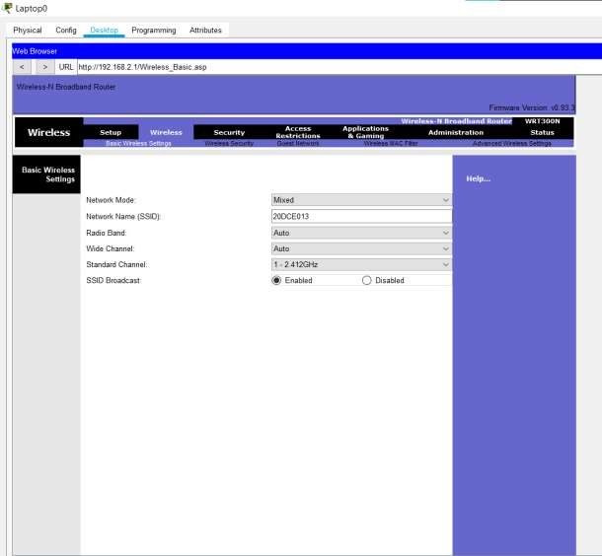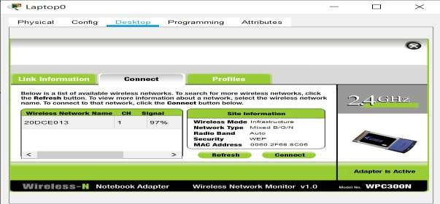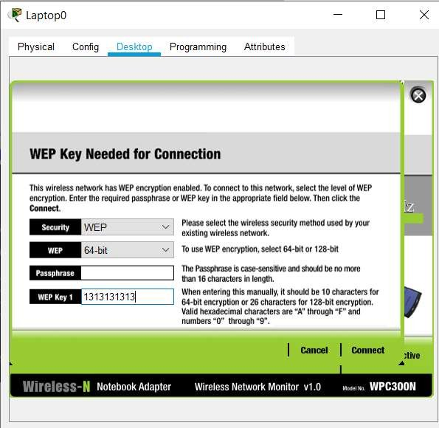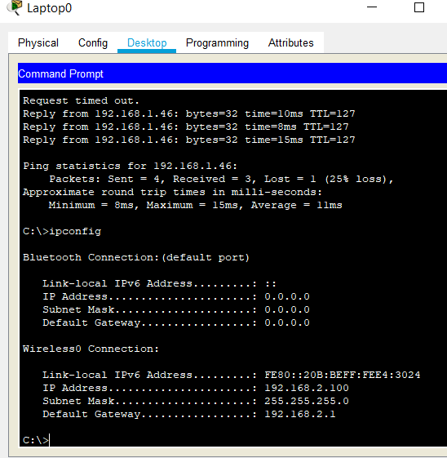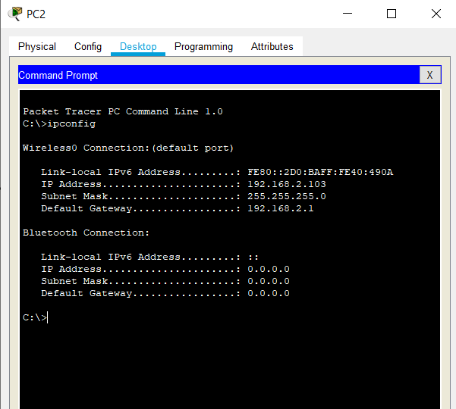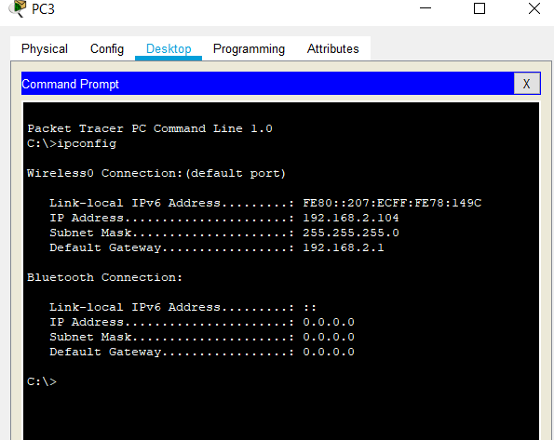

* Now lets ping PC2 from PC3.

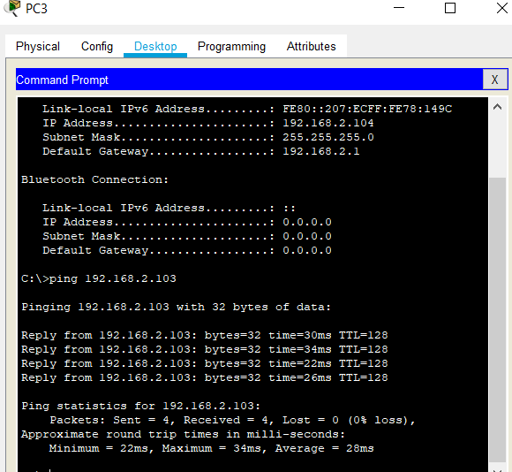

* Now Communication are establish between PC2 and PC3 through wireless router.
* Now we send message from PC2 to PC3.

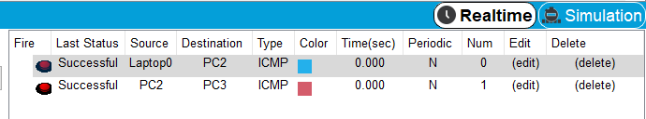

## **Conclusion:** In this practical we are understood how many types for cables and cable connector are required to network establishment and how to configure wifi setup using wireless router.